Analysing Housing Prices in Metropolitan Areas of India

Introduction:

House price prediction in a metropolitan city in India is a valuable solution for

potential home buyers, real estate agents, and invvestors. By leveraging

historical sales data, property details, and location-specific information, a

predictive model can accurately estimate house prices. The model's scalability,

real-time updates, user-friendly interface, and transparency ensure it meets

the needs of stakeholders. Integration capability, data privacy, and cost-

effectiveness are also important considerations. By addressing these

requirements, the prediction model provides reliable insights, empowering

stakeholders to make informed decisions in the fast-paced real estate mar

problem definition and Design thinking:

Empathy map and brainstorm:

<https://github.com/Pavithramurugan2004/Analysing-housing-prices-in-metropolitan-areas-of-India-_NM2023TMID41323/blob/main/Untitled_2023-10-15_05-41-50.pdf>

Empathy map:

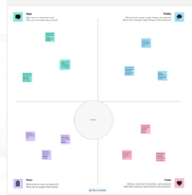

Brainstorm:

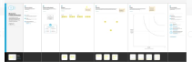

Result:

Hyderabad:1

<https://public.tableau.com/views/Dashboard1_16971935101740/Dashboard1?:language=en-US&publish=yes&:display_count=n&:origin=viz_share_link>

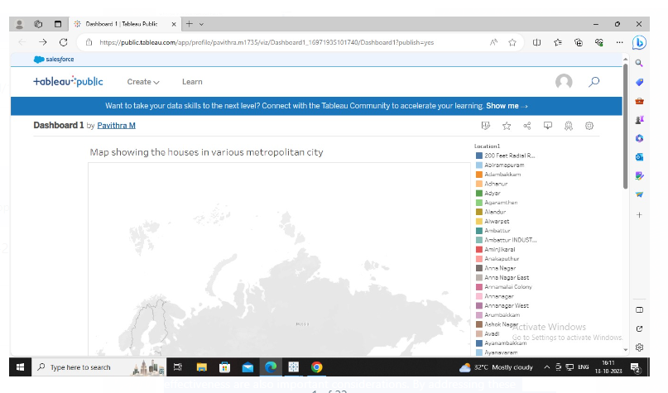

Hyderabad:2

<https://public.tableau.com/views/Dashboard2_16971938033460/Story1?:language=en-US&publish=yes&:display_count=n&:origin=viz_share_link>



Hyderabad:3

<https://public.tableau.com/views/dashboard3_16971950311680/Dashboard3?:language=en-US&publish=yes&:display_count=n&:origin=viz_share_link>

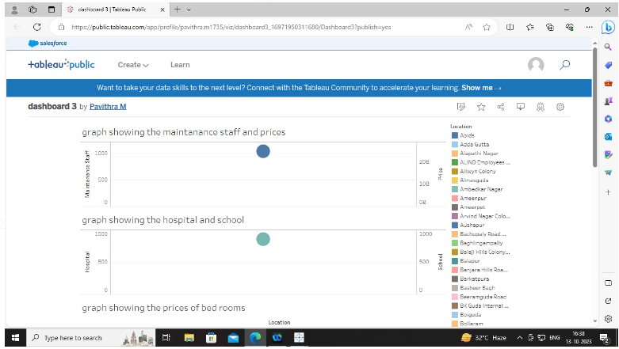

Hydeerabad:4

<https://public.tableau.com/views/dashboard4_16971955344390/Dashboard4?:language=en-US&publish=yes&:display_count=n&:origin=viz_share_link>

Chennai:1

<https://public.tableau.com/shared/BRMCM4HTK?:display_count=n&:origin=viz_share_link>

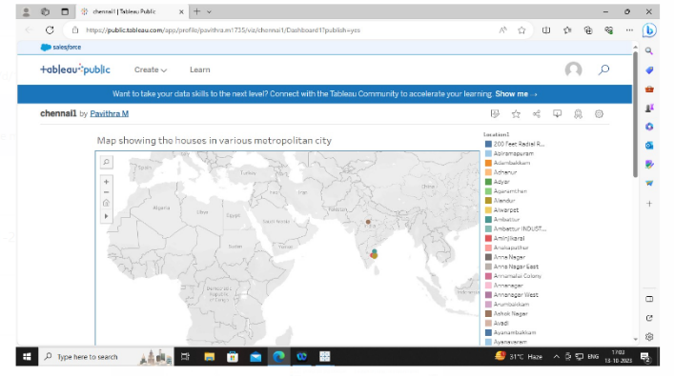

Chennai:2

<https://public.tableau.com/views/chennai2/Dashboard2?:language=en-US&publish=yes&:display_count=n&:origin=viz_share_link>

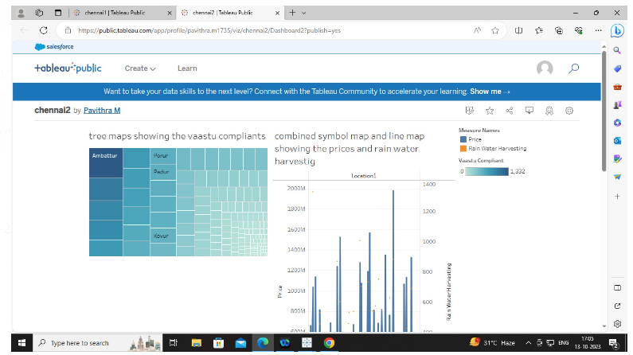

Chennai:3

<https://public.tableau.com/views/chennai3/Dashboard3?:language=en-US&publish=yes&:display_count=n&:origin=viz_share_link>

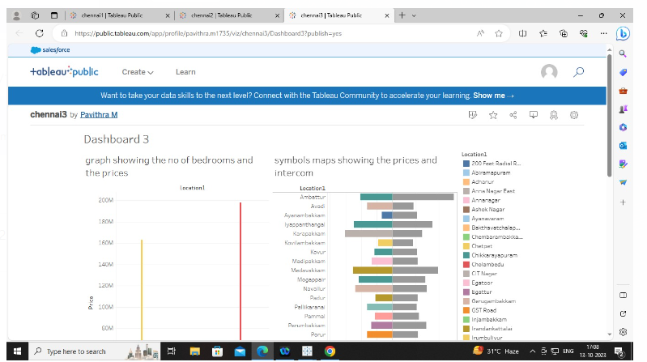

Chennai:4

<https://public.tableau.com/views/chennai4/Dashboard4?:language=en-US&publish=yes&:display_count=n&:origin=viz_share_link>

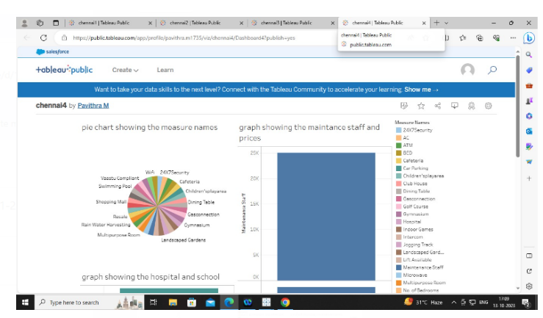

Delhi:1

<https://public.tableau.com/shared/DH57FMWTP?:display_count=n&:origin=viz_share_link>

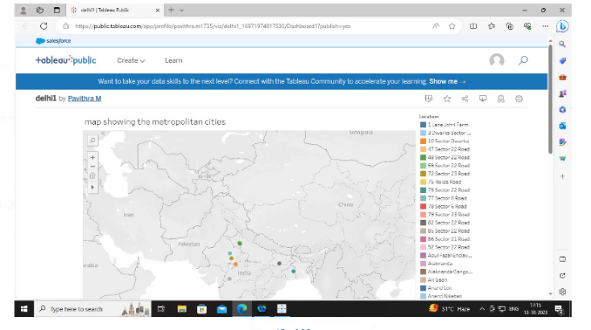

Delhi:2

<https://public.tableau.com/views/delhi2_16971976162740/Dashboard2?:language=en-US&publish=yes&:display_count=n&:origin=viz_share_link>

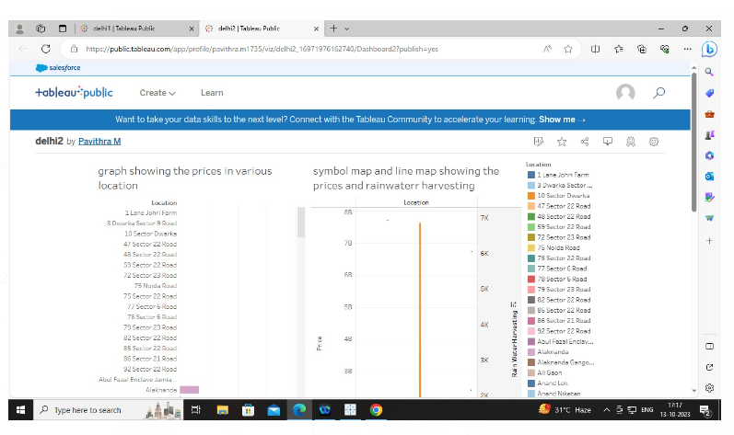

Delhi:3

<https://public.tableau.com/views/delhi3/Dashboard3?:language=en-US&publish=yes&:display_count=n&:origin=viz_share_link>

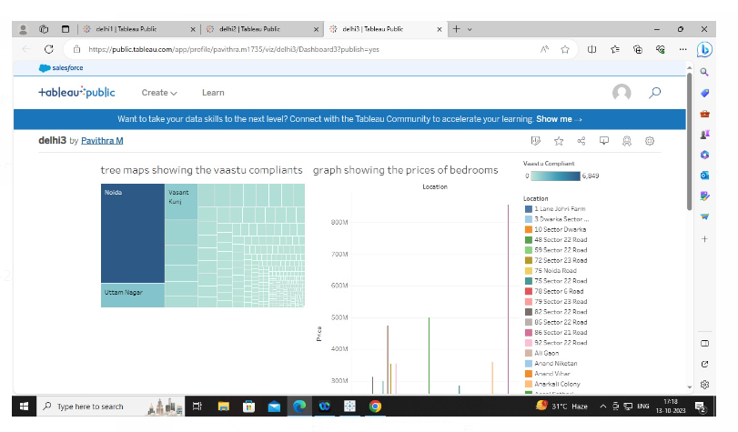

Delhi:4

<https://public.tableau.com/views/delhi4/Dashboard4?:language=en-US&publish=yes&:display_count=n&:origin=viz_share_link>

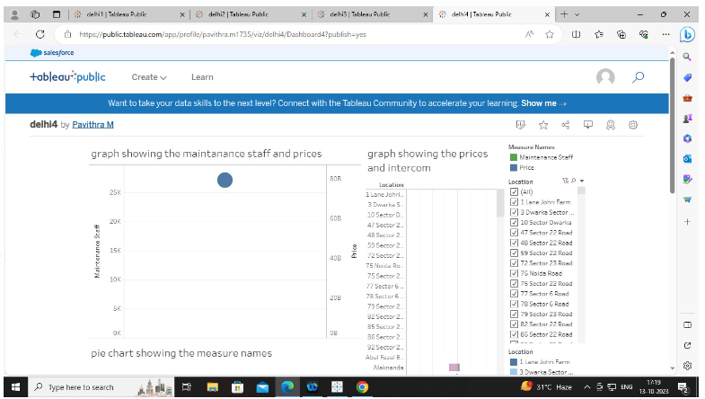

Bangalore:1

<https://public.tableau.com/views/bangalore1/Dashboard1?:language=en-US&publish=yes&:display_count=n&:origin=viz_share_link>

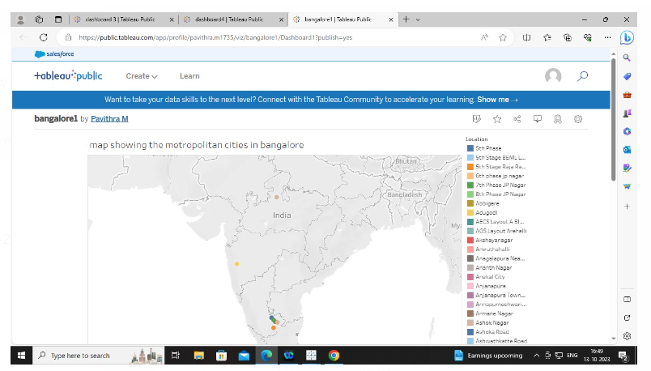

Bangalore:2

<https://public.tableau.com/views/bangalore2/Dashboard2?:language=en-US&publish=yes&:display_count=n&:origin=viz_share_link>

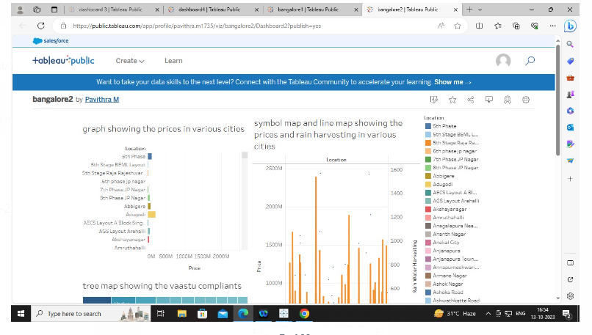

Bangalore:3

<https://public.tableau.com/views/bangalore3/Dashboard3?:language=en-US&publish=yes&:display_count=n&:origin=viz_share_link>

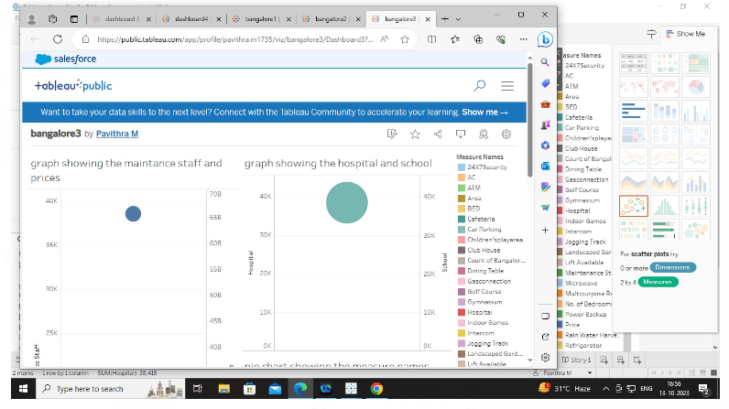

Bangalore:4

<https://public.tableau.com/views/bangalore4/Dashboard4?:language=en-US&publish=yes&:display_count=n&:origin=viz_share_link>

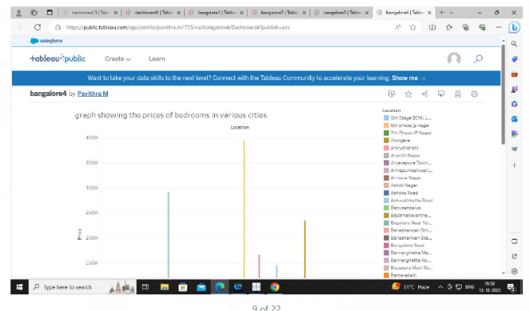

STORY:

Hyderabad:

<https://public.tableau.com/views/hyderabadstory/Story1?:language=en-US&publish=yes&:display_count=n&:origin=viz_share_link>

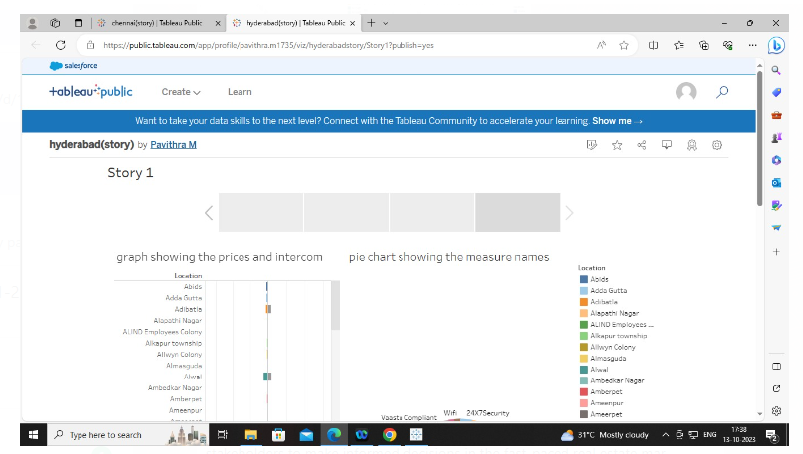

Chennai:

<https://public.tableau.com/views/chennaistory_16971986696400/Story1?:language=en-US&publish=yes&:display_count=n&:origin=viz_share_link>

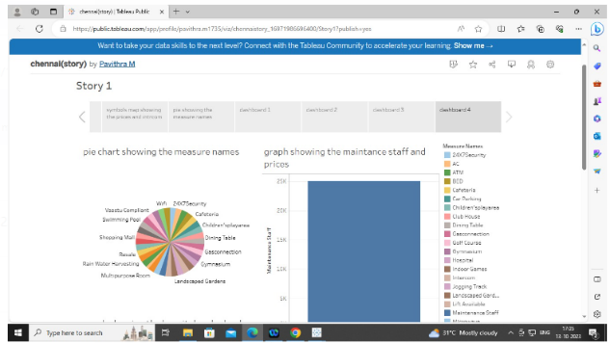

Bangalore:

<https://public.tableau.com/shared/P9MB4KFY8?:display_count=n&:origin=viz_share_link>

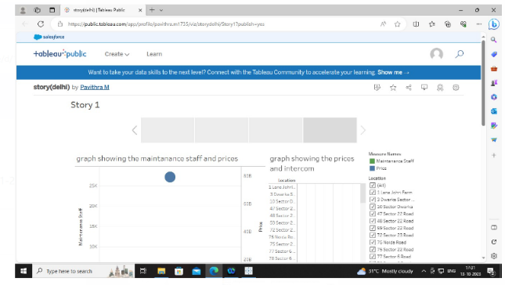

Delhi:

<https://public.tableau.com/views/storydelhi/Story1?:language=en-US&publish=yes&:display_count=n&:origin=viz_share_link>

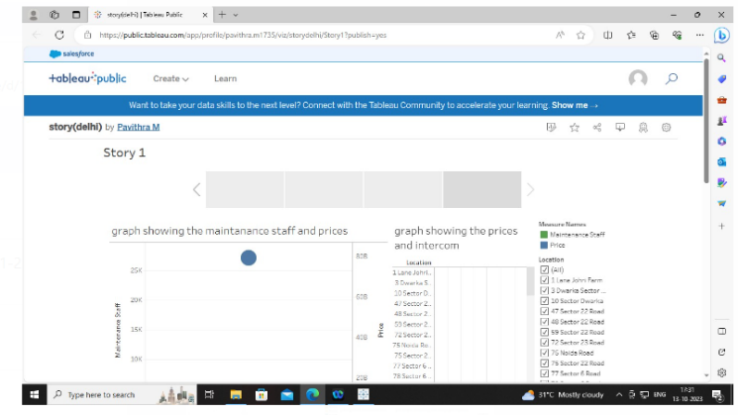

Conclusion:

The Indian real estate market is currently experiencing a period of growth, with housing prices rising in several cities across the country. Factors such as low interest rates, government initiatives, infrastructure development, and favorable demographics have contributed to this upward trend.